<!--This is the lab work and the purpose of this lab is to understand the basic concepts of the HTML and its tags. -->

<!DOCTYPE html>

<html lang = "en">

<head>

<title> HTML Basics - Lab Exercise </title>

<meta charset="UTF-8">

</head>

<body>

<h1> "Exploring HTML Tags"</h1>

<p> Hi my name is <b>Suresh Pandit</b> and I am TRU student. I am learning website design in this semester.<br/> I have lots of hobbies and my main hobby is to <i> coding and webstie designing</i>. </p>

<p> We are learning basics of the HTML right now. We have learned how to <em> build a webpage</em> using the basic <br/> concepts.We <em>learned how to write <strong> comments, heading, paragraphs.</strong></em> We learned about <strong> breaks, text <br/>formatting and about the head tags.</strong> </p>

<h2> "HTML TAG LIST"</h2>

<p> We learned about the HTML tags in previous session. There are various HTML tags and here we are discussing <br/>only of the five of them. Given below are the list of tags

Bold = <b>This is the example of bold tag</b></br>

Italic = <i>This is the example of italic</i></br>

Emphasized = <em>This is the example of emphasized</em></br>

Strong = <strong>This is example of strong emphasis tag</strong></br>

Defining heading = <h3>This is example of level3 heading</h3></br>

</p>

</body>

</html>

Results:

Part 2:

Gmail.com

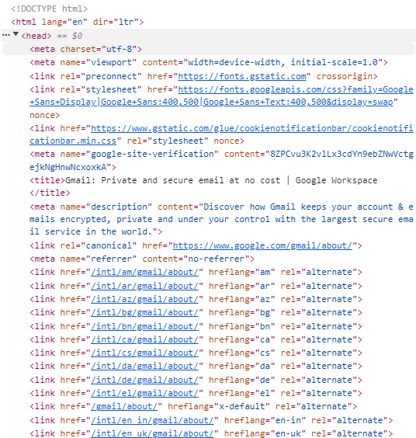Head Tag: This tag contains the metadata, title and the stylesheets. This contains some links as well. This also contains icon of gmail which is shown in the browser tab.

Google.com

Body: This tag contains the title and lost os the links . It has script as well

Wikipedia.com

Title: This tag contains the title of the Wikipedia which is shown when we open the browser.

It displays Wikipedia, the free encyclopedia.

